COAL Lab 05 Assignment:

# Name: Owais Ali Khan

# Section: 3-F

# Roll no: 21K-3298

Question # 01:

INCLUDE Irvine32.inc

.data

fibonacci DWORD 1

.code

main PROC

mov eax, 0

mov ebx, 0

mov ecx, 10

L1:

add eax, fibonacci

mov ebx, eax

sub ebx, fibonacci

mov fibonacci, ebx

call writeInt

call Crlf

loop L1

exit

main ENDP

END main

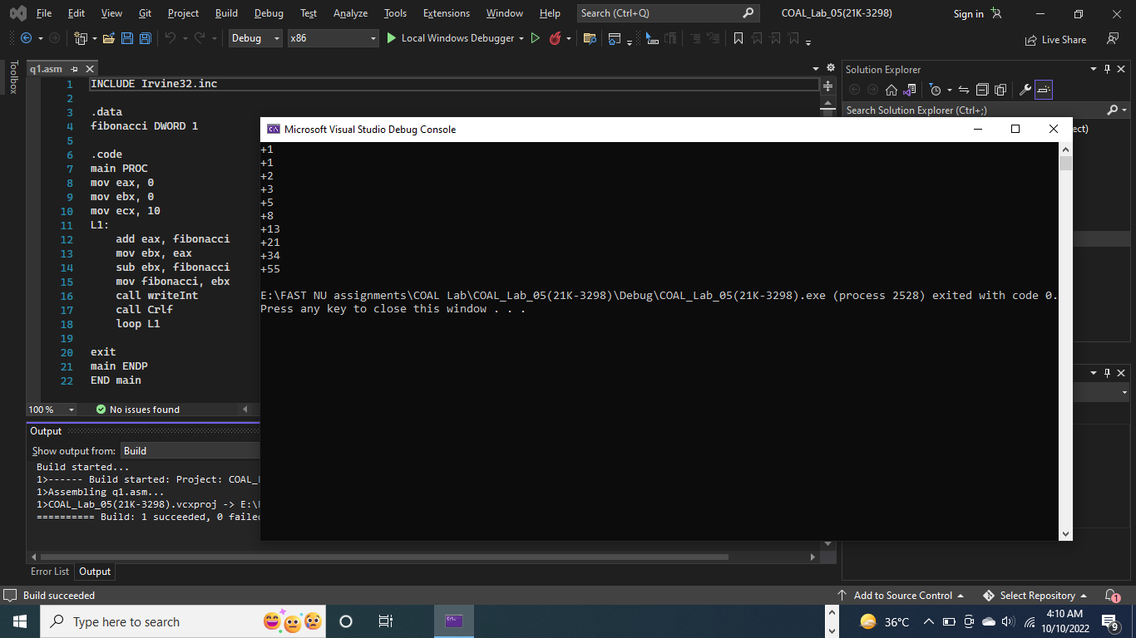

Question # 02:

INCLUDE Irvine32.inc

.data

array DWORD 8,5,1,2,6

.code

main PROC

mov esi, 0

mov ecx, LENGTHOF array

PRINT1:

mov eax, array[esi]

add esi, TYPE array

call writeInt

loop PRINT1

call Crlf

mov eax, 0

mov ebx, 0

mov ecx, LENGTHOF array - 1

L1:

mov esi, 0

L2:

cmp esi, (SIZEOF array - (2 * TYPE array))

jg L3

mov eax, array[esi]

mov edx, array[esi + 4]

cmp eax, edx

jg swap

add esi, TYPE array

jmp L2

L3:

loop L1

cmp ecx, 0

je ENDD

swap:

mov eax, array[esi]

xchg eax, array[esi + 4]

mov array[esi], eax

add esi, TYPE array

jmp L2

ENDD:

mov esi, 0

mov ecx, LENGTHOF array

PRINT2:

mov eax, array[esi]

add esi, TYPE array

call writeInt

loop PRINT2

exit

main ENDP

END main

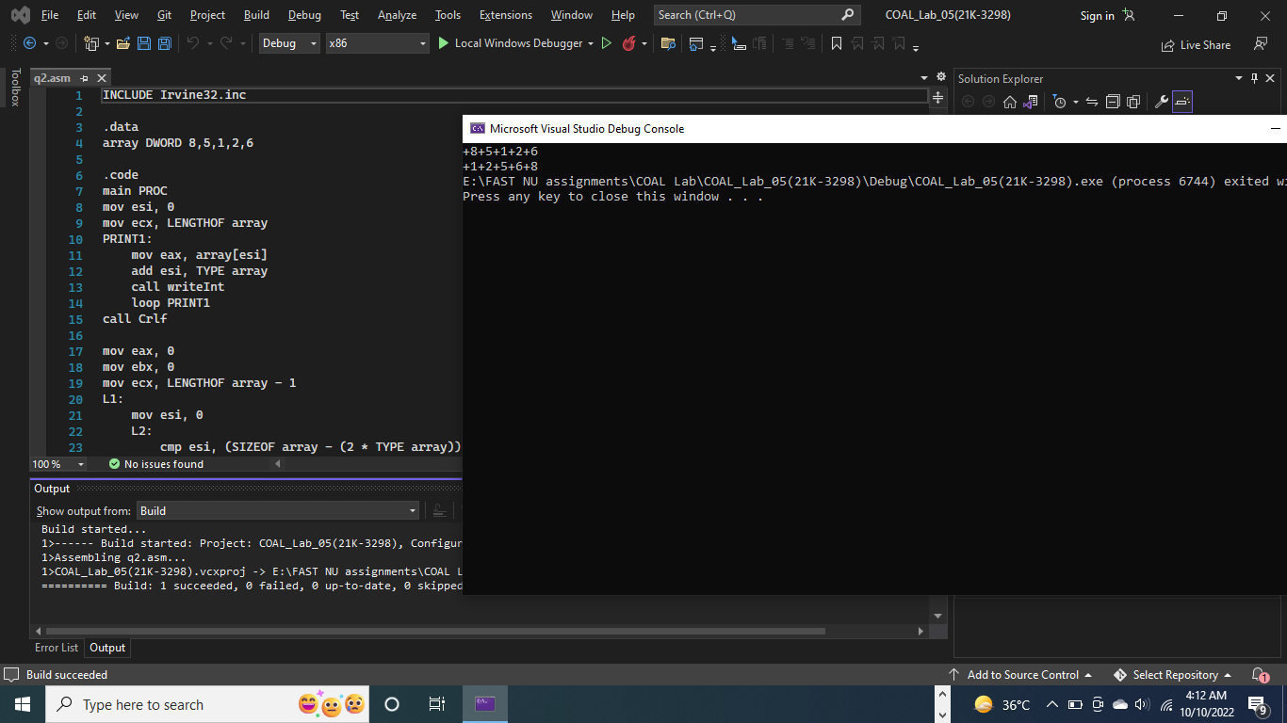

Question # 03:

TITLE Question 3

INCLUDE Irvine32.inc

.data

loopCounter DWORD 4

.code

main PROC

mov eax, 1

mov ecx, loopCounter

L1:

mov edx, ecx

mov ecx, loopCounter

sub ecx, edx

add ecx, 1

L2:

call writeDec

loop L2

mov ecx, edx

call Crlf

loop L1

call Crlf

mov ecx, loopCounter

L4:

mov edx, ecx

L5:

call writeDec

loop L5

call Crlf

mov ecx, edx

loop L4

call Crlf

mov ecx, loopCounter

L6:

mov edx, ecx

mov eax, 4

L7:

call writeDec

dec eax

loop L7

call Crlf

mov ecx, edx

loop L6

call Crlf

mov ecx, loopCounter

L8:

mov edx, ecx

mov eax, 1

L9:

call writeDec

inc eax

loop L9

call Crlf

mov ecx, edx

loop L8

exit

main ENDP

END main

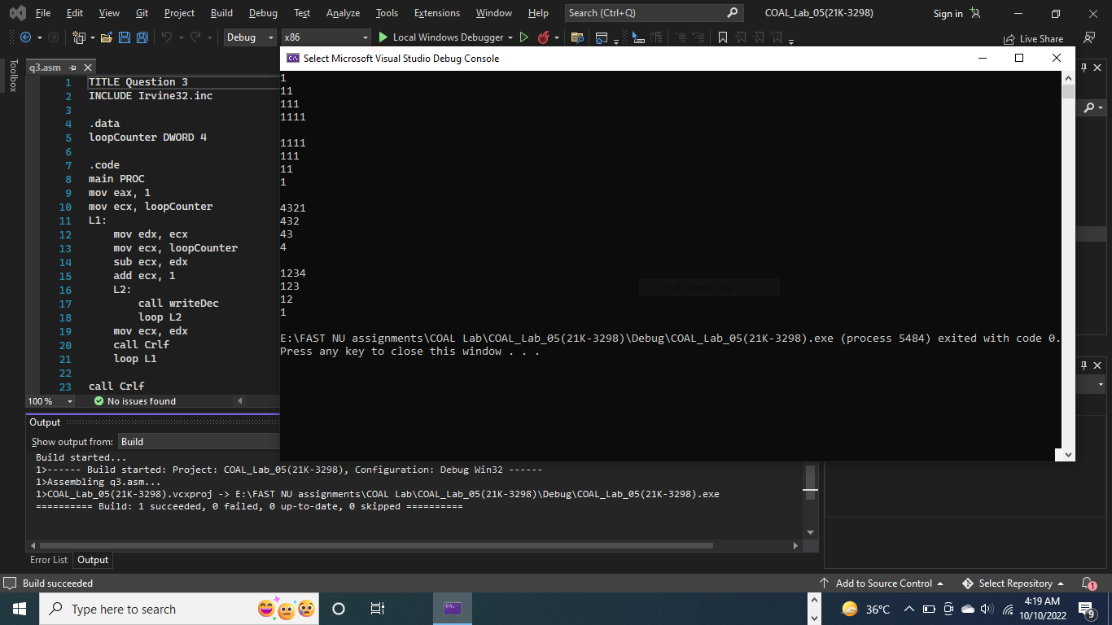

Question # 04:

INCLUDE Irvine32.inc

.data

stringSize = 10

TotalSalary DWORD 0

Employee DWORD ?, stringSize DUP(0), 0, ?, ?

DWORD ?, stringSize DUP(0), 0, ?, ?

DWORD ?, stringSize DUP(0), 0, ?, ?

DWORD ?, stringSize DUP(0), 0, ?, ?

DWORD ?, stringSize DUP(0), 0, ?, ?

ID BYTE "Enter ID of Employee: ", 0

ID_2 = ID + 6

EmpName BYTE "Enter Name of Employee: ", 0

EmpName_2 = EmpName + 6

Year BYTE "Enter Year of Employee: ", 0

Year_2 = Year + 6

Salary BYTE "Enter Salary of Employee: ", 0

Salary_2 = Salary + 6

Salary_3 BYTE "Total Salary of all employees: ", 0

.code

main PROC

mov eax, 0

mov esi, 0

mov ecx, 5

INPUT:

mov edx, OFFSET ID

call WriteString

call ReadInt

mov Employee[esi], eax

add esi, TYPE Employee

mov edx, OFFSET EmpName

call WriteString

mov edx, OFFSET Employee

add edx, esi

push ecx

mov ecx, stringSize

call ReadString

pop ecx

add esi, stringSize * TYPE Employee

mov edx, OFFSET Year

call WriteString

call ReadInt

mov Employee[esi], eax

add esi, TYPE Employee

mov edx, OFFSET Salary

call WriteString

call ReadInt

mov Employee[esi], eax

add TotalSalary, eax

add esi, TYPE Employee

call Crlf

loop INPUT

mov esi, 0

mov ecx, 5

PRINT:

mov edx, OFFSET ID_2

call WriteString

mov eax, Employee[esi]

call WriteDec

call Crlf

add esi, TYPE Employee

mov edx, OFFSET EmpName_2

call WriteString

mov edx, OFFSET Employee

add edx, esi

call WriteString

call Crlf

add esi, 10 * TYPE Employee

mov edx, OFFSET Year_2

call WriteString

mov eax, Employee[esi]

call WriteDec

call Crlf

add esi, TYPE Employee

mov edx, OFFSET Salary_2

call WriteString

mov eax, Employee[esi]

call WriteDec

call Crlf

call Crlf

add esi, TYPE Employee

loop PRINT

mov edx, OFFSET Salary_3

call WriteString

mov eax, TotalSalary

call WriteDec

call Crlf

exit

main ENDP

END main

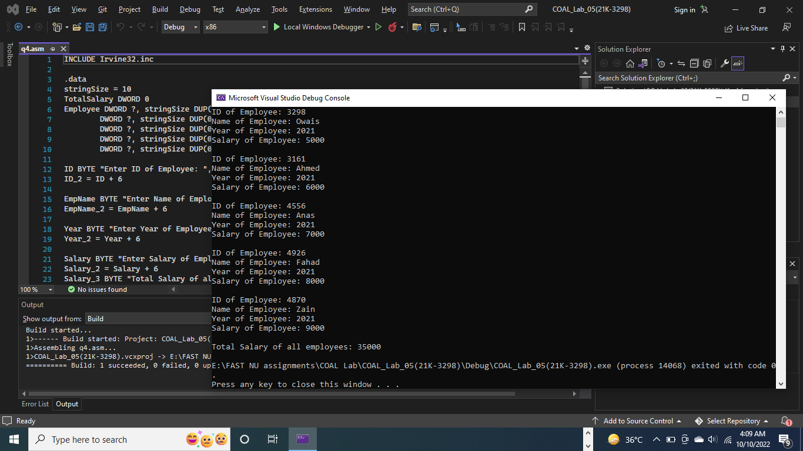

Question # 05:

INCLUDE Irvine32.inc

.data

source BYTE "Owais Ali Khan", 0

target BYTE SIZEOF source DUP(?), 0

.code

main PROC

mov eax, 0

mov esi, 0

mov ecx, LENGTHOF source

L1:

mov al, source[esi]

mov target[esi], al

add esi, TYPE source

loop L1

mov edx, OFFSET source

call writeString

call Crlf

mov edx, OFFSET target

call writeString

exit

main ENDP

END main

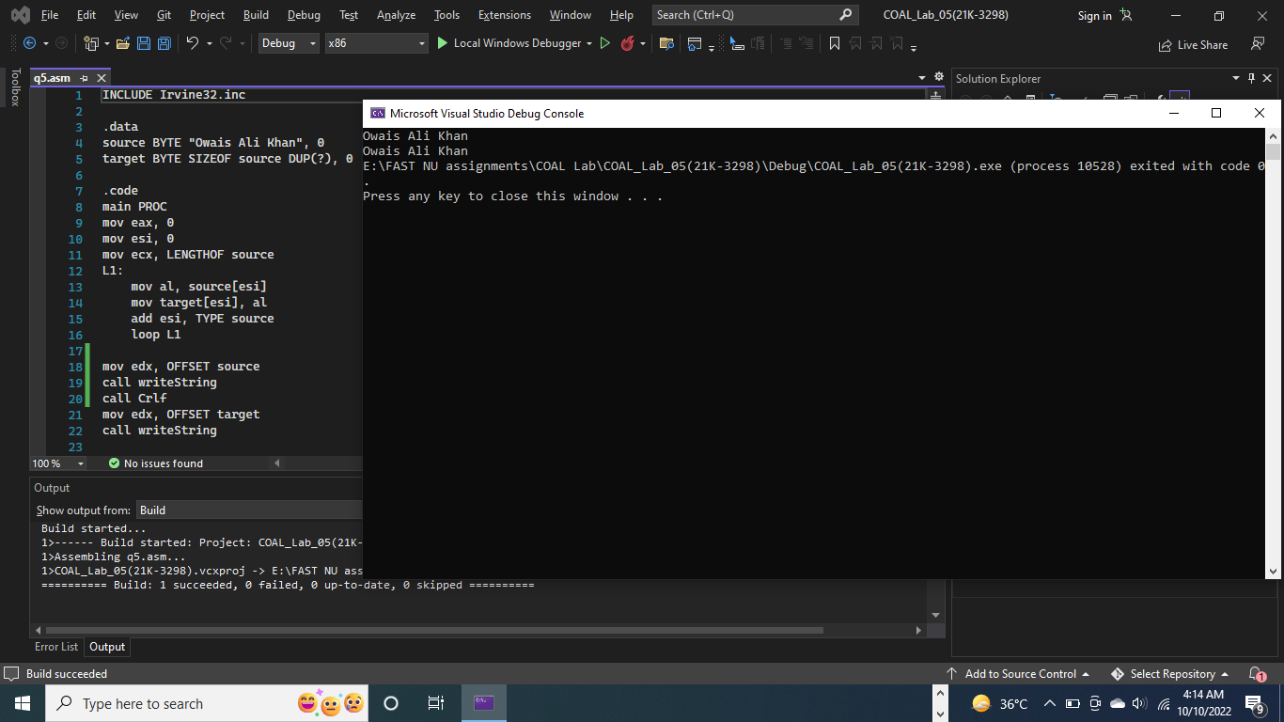

Question # 06:

TITLE Question 3

INCLUDE Irvine32.inc

.data

array DWORD 0,1,2,3,4,5,6,7,8,9

.code

main PROC

mov eax, 0

mov esi, 0

mov ecx, LENGTHOF array

PRINT1:

mov eax, array[esi]

call writeDec

add esi, TYPE array

loop PRINT1

call Crlf

mov esi, 0

mov edi, SIZEOF array - 4

mov ecx, LENGTHOF array / 2

Reverse:

mov eax, array[esi]

xchg eax, array[edi]

mov array[esi], eax

add esi, TYPE array

sub edi, TYPE array

cmp esi, edi

jge ENDD

loop Reverse

ENDD:

mov eax, 0

mov esi, 0

mov ecx, LENGTHOF array

PRINT2:

mov eax, array[esi]

call writeDec

add esi, TYPE array

loop PRINT2

call Crlf

exit

main ENDP

END main

